MODULE 5: ANCIENT OLYMPIC GAMES (TEAM 2)

The aim of the Sports module (team 2) was to introduce the guest pupils to Ancient Olympic Games and encourage active participation in one of them.
During the lesson the guest pupils were presented with the different categories of the Ancient Olympic Games as well as their basic rules.
Then we proceeded to a comparison/contrast between the Modern and Ancient Olympic Games and we discussed the differences/similarities of the athletes’ way of living (old times Vs nowadays).
The theoretical part of the lesson came to an end by explaining the ‘creation’ of the sports and their relation to human survival.
Regarding practice there was a presentation of discus throwing with an emphasis to the technique itself. With the help of volunteer Greek pupils all the guest students along with their teachers participated in the teaching/practice of the discus throw.
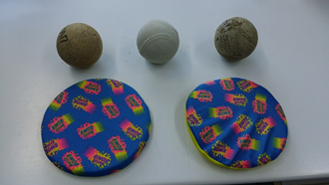
Discus throw games followed. The pupils were invited to alternate roles between judges and discus throwers with a view to helping them consolidate the regulations governing the particular event.
In the end, the guest pupils were awarded medals.
