MY VISIT TO ROMANIA
By NICK ALEXOPOULOS (5th grader)
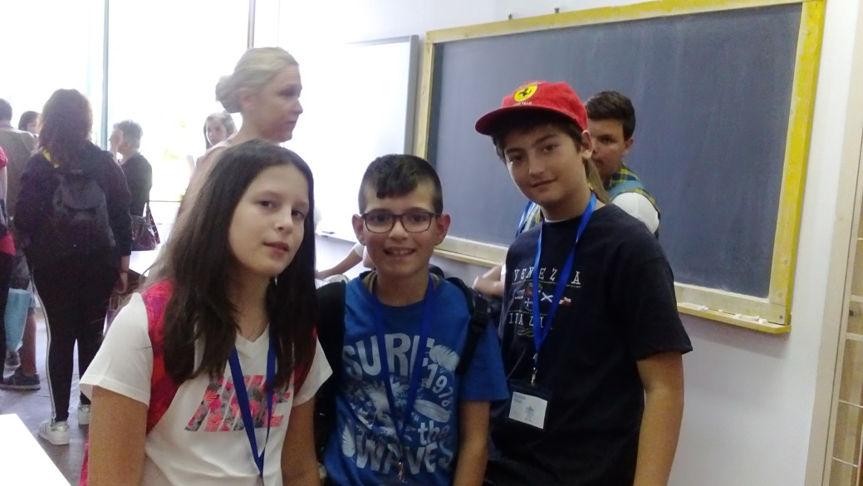
Last month, I visited Romania with the school programme “Erasmus+”. Romania is fantastic. We visited a lot of famous places there. During the first day, we went to Alba Iulia by bus. It is a historical and interesting place with an old traditional castle. We had a lovely time there! Also, we visited an Orthodox monastery and then, we went to school at about six o’clock. The second day, we visited the school which participates in this programme, Alexandru Vaida-Voedod. We saw different classes and we attended a school performance.
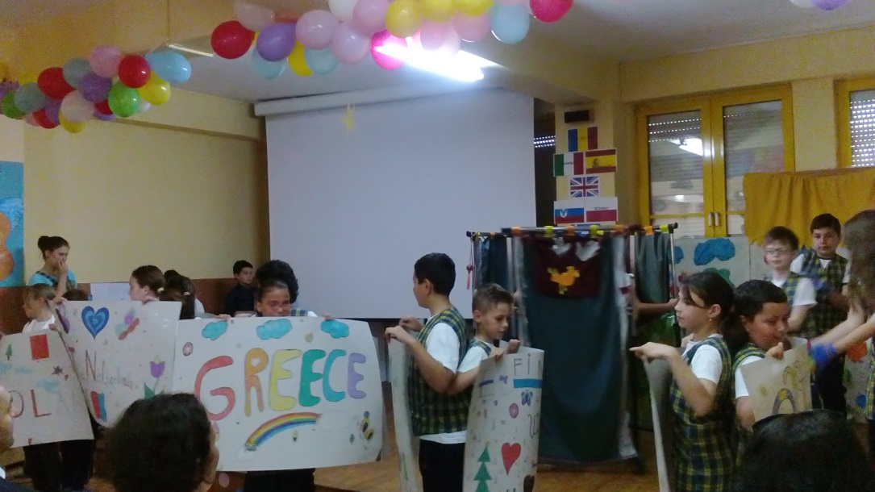

After that, we went to the city centre of Cluj- Napoca and we visited a lot of great churches/cathedrals of various architectural styles. They are really fantastic! We also had a guide who was explaining everything to us. We learned so much! The following day, we went to a house, changed into a traditional museum. There we had the chance to learn how to cook and do other things, as well. The fourth day, we went to school again and we learnt dancing and sewing together with the Romanian students. I really enjoyed it! The strange and the best thing was that all the boys managed to sew for the first time in their life. Really entertaining! In the afternoon of the same day, we went back to school because the participants of each country should bring traditional food. We tasted lots of different recipes! Then we saw a video which showed the presentation of each country. The last day, we visited a salt mine, Salina Turda. Down there it was very cold, but the experience of going down using so many stairs and going back by the glass lift was enjoyable! Then, we visited the Botanic Garden. For me, the best of all the sights was the Botanic Garden because I love flowers and nature.
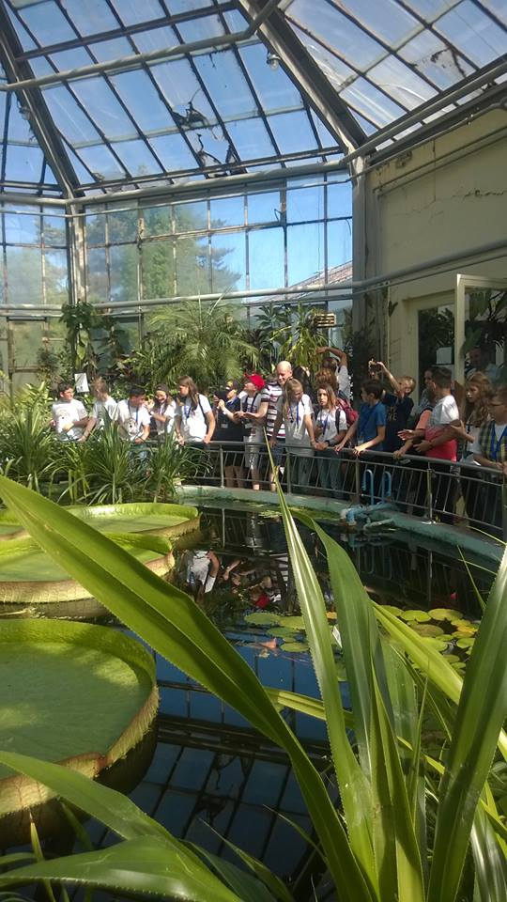
As far as my host family is concerned, I can say that all of them were very kind and sweet.. They had a lovely cat, but an aggressive dog!!! I had a big room, the parents’ bedroom. I sometimes played with Mihai (the Romanian boy of my age) on computer and we listened to music. The dad, the mum and the brother, Danny, were very kind and they offered all the time food to me. The thing I liked best was the visits with the family and the ice-creams they offered to me. Moreover, the last day, they brought me a lot of presents. I was so happy! Romania was fantastic and I hope that one day I will visit it again.

